Ideation Phase
Define the Problem Statements
Date | 18 February 2026
Team ID | LTVIP2026TMIDS24123
Project Name | Civil Engineering Insight Studio
Maximum Marks | 2 Marks

Customer Problem Statement Template
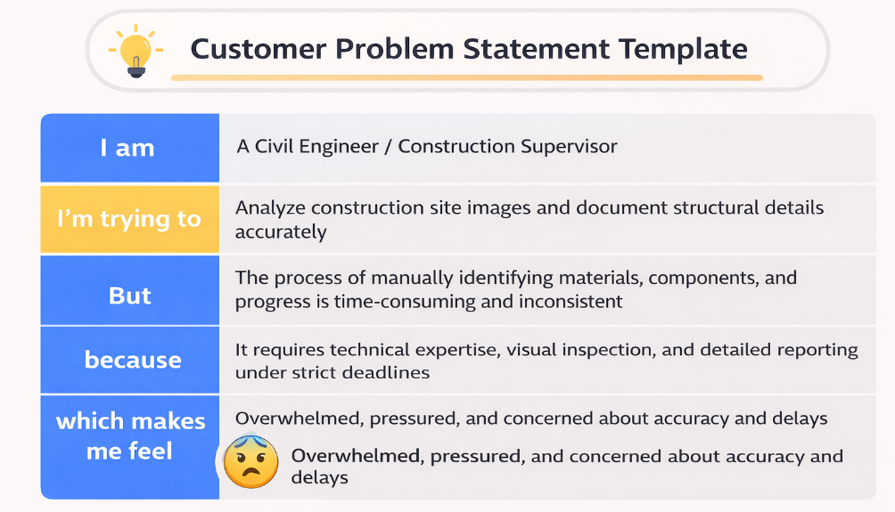
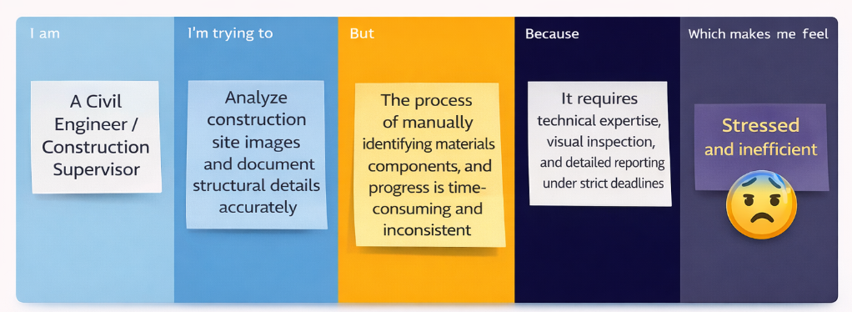

Problem Statement (PS) | I am (Customer) | I’m trying to | But | Because | Which makes me feel
PS-1 | A Civil Engineer / Construction Supervisor | Analyze construction site images and document structural details accurately | The manual process of identifying materials, components, and project progress is time-consuming and inconsistent | It requires detailed visual inspection, technical expertise, and reporting under strict deadlines | Overwhelmed, pressured, and concerned about accuracy and delays
PS-2 | A Project Manager in a Construction Firm | Monitor project progress and communicate structured updates to stakeholders | I do not have an automated system that converts site images into standardized technical documentation | Reporting is manually prepared and varies between team members | Frustrated, uncertain about consistency, and concerned about tracking efficiency

